The Gallery Writers, Meldreth

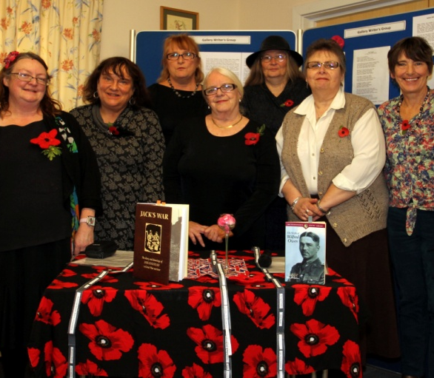

The poetry and prose shown below was read at the World War 1 Exhibition held in Meldreth on 9th November 2014.

All the poetry and some prose was either the writer’s own work or they read a favourite piece about WW1.

Their involvement with our WW1 project added another aspect to the exhibition and was appreciated by all who heard and read their work.
Many thanks to the Gallery Writers .

Joan Gane, MLHG Chairman

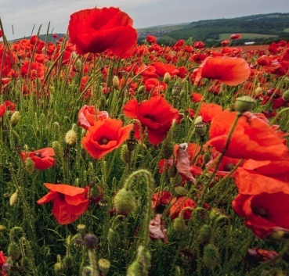
Indelible: (In Loving Memory).

We did not have to go; remained to knit
and sew, hold jumble sales, find socks
and blankets for our brave men at the front.
How we tossed and turned at night,
we only whispered to close friends,
heads bent below the Union Jack,
pretending it was our endeavour.

What we gave was waiting.
Watched from windows, hoped
there was no one at the gate.
Grew used to saying: ‘He was the bravest
and the best’. Laid hands on arms. Re -read
the cheerful lying letters received on the
embroidered postcards, they sent on leave.

It wasn’t until later at the comings home,
the Hospital down the lane:
the men who couldn’t show their faces,
eyes in well, holes for a nose, cheeks
showing muscles red like meat, two or three
lost limbs. Some so haunted, they could
not sleep, were taken screaming to the asylum.

We tried to comfort, bend, lift and listen.
Indelible, we could not wash and bandage it.
They did not want the pity.
So in loving memory, light a candle for
those country men; Fuller, Fielding, Negus,
Pepper, Farnham, East, Flack, Harrup, Dash
and Chamberlain. Those pals.

And for us, please don’t mention loyalty and angels,
Refuse the raffle to guess the name of dolls.
No patriotic songs will restore the faces of
brothers, fathers, sons, whose children only
know them now, as poppies.

Clare Crossman

Clare has used the names of Meldreth men who lost their lives in WW1
The Poppy

(A Poem for the young)

Why is it so symbolic?
Fragile scarlet little flower.
Petals flutter falling in the breeze
What constitutes the poignant power?

Undisturbed and buried deeply underground
Corn poppy seeds can survive for years,
But disturb that soil to see the light
And a new fresh flower soon appears.

Napoleon’s wars churned bare land
Into fields of blood red poppies
Growing scarlet, like the blood
Around the soldiers’ fallen bodies.

Once again a great war raged,
1914-18 was its dreadful span.
Once more in earth disturbed and torn.
Poppy growing once again began.

In Belgium’s fields in Flanders
The poppy bloomed again,
Feeding on a great war’s strife,
That left a legacy of pain.

Now you young ones, don’t ask ‘why’?
As now you know the poppy’s special story.
As to why it is that symbol proud,
To honour those who died, give them glory.

The poppy means Remembrance,
Worn with such pride and sorrow,
Commemorating those who fought so hard:
Giving their today for us to have tomorrow.

Yvonne Chamberlain 17/10/2014

A WW1 War Story
I lived with me Da, Albert, Ma, Edith and I was the fourth of seven siblings, Ralph, Aggie, Simon, then Harold, Lizzie and Alfred, the twins, and the bairn Olive.
I were 15 year old, nearly 6 feet tall and of medium build. I’d eat a horse but would never gain weight. I left school at the age of 13 and started as an apprentice at the local steel factory where me Da had been employed all his working life. Brothers Ralph and Simon got apprenticeships in the glassworks and me sister Aggie and Lizzie went into service. Alfred would never be able to work. He got Polio as a bairn and his legs never worked so Ma cared for him.
I hated the steel works. It was dirty, smelly and agonisingly hot. It was affecting me Da’s health. He found breathing difficult and at night sometimes he would sit up to relieve his coughing. He did not realise we knew that he were coughing up blood almost everyday.
Da was a man of only 38 years of age.
At 15 year old I wanted more in life. There had been talk for many months of war with Germany. I did not know a lot about it, but it soon came to pass. It had been declared. We were at war to Germany.
Many of the older lads had left the village and gone to the War Office and had been assigned to different regiments and I had decided that this is what I wanted to do, win the war for King and Country. I knew this were me destiny.
I walked into town and caught the tram into the city and walked the distance to the army recruitment office.
I lined up with the other hopefuls.
I were called forward and asked me name.
‘ Harold Dowling Sir’.
‘Age Dowling?’
’18 Sir’
He looked at me under his eyelids. He had a large bushy moustache, short cropped ginger hair under a tight fitting peaked Kepi which were pulled over his forehead. 3 stripes sat proudly on his sleeve.
’18 ya say’
‘Yes Sir’
‘When was ya born lad?’
‘1896 Sir’. I had practised this in case I were asked.
He again asked me my age and when I was born. I put my chin down on me chest. It helped to make me voice have a deeper tone.
I was sent to the Army Doctor who checked me eyes, ears, chest and me feet, to see if they were flat. Then, he grabbed me knackers and asked me to cough. I were given a paper to say I were fit and told to go and collect me uniform. I were given 2 vests, 2 shirts, 2 pair of long shirts, 2 pair a long johns, 4 pairs a socks, a great coat, knapsack and a pair of army issued boots that were too small for me size 12 feet but were told they would soon soften up to fit.
I put on me uniform which I felt like wearing pan scourers. It were itchy and uncomfortable, but I were told like me boots it would soften up.
I signed me name to a piece of paper and walked out with the King’s shilling.
Written by Yvonne Smith, 2014
( Best read with a Geordie accent)

The Send-off

Down the close, darkening lanes they sang their way
To the siding-shed,
And lined the train with faces grimly gay.
Their breasts were stuck all white with wreath and spray
As men's are, dead.
Dull porters watched them, and a casual tramp
Stood staring hard,
Sorry to miss them from the upland camp.
Then, unmoved, signals nodded, and a lamp
Winked to the guard.
So secretly, like wrongs hushed-up, they went.
They were not ours:
We never heard to which front these were sent.
Nor there if they yet mock what women meant
Who gave them flowers.
Shall they return to beatings of great bells
In wild trainloads?
A few, a few, too few for drums and yells,
May creep back, silent, to still village wells
Up half-known roads.
By Wilfred Owen
Read by Elizabeth Williams

EMILY’s LAST DAY
(Based on the real story of the death of Suffragette, Emily Wilding Davidson on June 4th 1913. Written by a fellow Suffragette.)
-------------------------------------------------------------------------------------------
Dear Diary,
I haven’t written in you for a week or two, so now is the time for me to bring you up to date. I’m writing about one of the most dramatic moments of my life.
The day dawned cloudy, cold and grey. I was with my friend and fellow Suffragette, Emily, on a train to the Epsom races.
We both have a Suffrage flag wound around our waists under our long, coats. Emily had another flag wound tightly round her wrist which no-one could see.
When we got off the train at Epsom the atmosphere at the races was enthusiastic and energetic. Emily had puzzled me when she refused to tell me what she was going to do.
Typical Emily. All I knew was that we both had race cards and were going to watch the horse races. Though she did say to me in her enigmatic way, “You wait till you read the evening papers tomorrow, my friend!” and gave a wry smile.
The first race was at 1.30 pm. I followed Emily who squeezed easily with her tiny frame into the front row at Tattenham Corner. We were amongst a jostling crowd. I remember a horse called Marco Polo won the second race and I wrote it down on my race card.
I’ll never forget what happened next………………..
As the horses thundered round Tattenham Corner, Emily suddenly pushed forward and broke through the railings directly in front of the horses. It looked as if she was trying to grab hold of the King’s horse’s bridle with a Suffragette flag of green, purple and white.
At this electric moment with the other horses thundering past, the King’s Horse, Anmer, appeared to fall on top of Emily and kicked furiously.
Emily lay unconscious on the ground. In that confused moment, I noticed her race-card lying a few feet away. Meanwhile, Anmer struggled to his feet as his jockey remained unsaddled on the ground.
In the ensuing panic, a swell of spectators, myself included, ran onto the course .I was stunned and realised I could never have anticipated Emily running out deliberately to knock herself out under the powerful horses’ hooves.
She lay on the ground and I feared she was dead. She looked terrible: this was the woman I had been talking and laughing with few moments earlier. All the blood and life had drained from her face and she was completely still. I remember noticing that the sleeve of her black dress was torn and her skirt was in shreds.
The blow to the head from the horse’s hooves had left her hair tangled and matted now with ruby red streaks. I stayed next to her and later accompanied her to the Cottage hospital in the ambulance, praying for a sign of life.
The next few days were a nightmare. I kept vigil over Emily with her mother and her close members of her family and fellow Suffragettes. I prayed for her life with all the energy I had left in me. But it was all in vain. She never came out of the coma and died three days later on 8 June, 1913.
Even though her death was accidental, I felt that I had never, ever until that terrible day, recognised the full force of Emily’s reckless and martyring spirit. She was a close friend, a comrade in arms, a fellow hunger striker in prison and a pioneer for the Suffrage cause. I was devastated. I could not believe that Emily was dead. It was tragic and I miss her beyond words. Read by Eleanor Fitzgerald

The A-Z of MISFORTUNE (1914-1918)

For the Lucky Ones there was:
Armistice
Brotherhood
Cuts and grazes, Camaraderie
Discomfort, Dread
Eluding bullets, Evacuation
Fear
Good health
Hopes of Home
Injury
Journeys to foreign lands
Kindness
Letters, Love and LIFE
Medals, Mercy
Near miss, then Nurtured by kindly Nurses
Optimism
Peace declared
Quiet
Red Cross Parcels, Rescue, Repatriation
Salvation, Sanity
Tears and Threats
Unable to enlist
Victory ,Vindication
Wounds
X marks the spot of another’s fate
Yearning for Home
Zest for LIFE

For the Not So Lucky Ones:

Amnesia
Blood, Betrayal
Collapse
Delirium, Disfigurement
Excruciating pain
Flashbacks, FATE
Gas
Hardship, Hatred
Insomnia
Jeopardy
Killing (on orders, comrades at dawn)
Life threatening diseases
Morbid Memories
No Man’s Land, Nausea
ORDERS TO BE OBEYED (over the top or shot at dawn)
Pain
Quivering with
Raging fever....
Scars
Trauma
Unable to escape, Unconscious from blasts
Violence
Wire, no Warning
X marked the line where he signed his life to others
Yielded to bullets
ZERO HOUR

Finally for the Really Unlucky Ones:

Amputees, living in Asylums
Blindness, Burns
Conscription, No CHOICE but
DEATH
Execution by
Firing squad, Frostbite
Gangrene
Haemorrhage
Injustice, Interment, Inhumanity, Insanity
Jaded
Limbs lost
Murdered in the Massacre
No Return – left where he fell
Obliterated
Posthumous Pardon
Queuing up to become the next victim
Ravaged bodies
Shell Shock
Ugly faces, maimed
Violated
Waste of Life, WHY? WHAT FOR?
War to end all wars (it wasn’t)
X marks the spot where they fell
Youth lost,
ZAPPED in the Zenith of their youth

Written by Hilary Sugai

